International application No.

PCT/GB2011/001556
Applicant: MILLER, Peter Anthony
e-mail: p.a.miller2@btopenworld.com
Global recycling of the earth’s natural resources
DESCRIPTION
Background
The world is confronted with a major issue regarding TWO intertwined facts of modern life closely linked to contemporary environmental pollution and the rapid disappearance of the natural resources of the earth.
Two major natural resources are at the core of this trend:
- Fossil fuel for energy generation, transport & carbonaceous products
- Potable water

Over 4 billion years ago the earth was still a lifeless inhospitable place.
An extensive crust had probably already formed, whereby decreasing surface temperatures caused the condensation of vast amounts of superheated water vapour forming today’s oceans charged with dissolved carbon dioxide gas.
The concoction SUN, SEAWATER & CARBON DIOXIDE provided the basis of nature’s greatest invention: PHOTOSYNTHESIS.
There is an urgent need for mankind to curb the present combustion of ca. 2 billion tons/annum of fossilized carbon.
For the continued survival on planet-earth, Nature’s fortuitous inventions of photosynthesis and the concomitant so-called “carbon neutral recycling process” must now be followed up and improved upon by mankind.
The contemporary reckless rate of plundering of the remaining fossilized carbon and mineral reserves in the earth’s crust is obviously unsustainable and although there is a general consensus concerning this there is still no convincing plan for rectifying the situation.
There are convincing environmental, economic and political reasons for this:
Environment
The ever-dwindling reserves of fossilized carbon and its concomitant ever increasing price will continue to provide the impetus to ever-increasing intrusive methods of finding and extracting the last traces of fossil carbon in the earth’s crust. This trend has already caused irreversible pollution of the remaining fresh water reserves both above and below the earth’s surface.
Economics
The spiralling price of fossil fuels over recent decades is a major contributor to the present economical upheavals and famines. At present fossilized carbon monopolizes not only the global energy market but also provides the basic raw materials for most of the common articles and commodities of everyday human life from clothing and furnishings to chemicals and pharmaceuticals. The pressures brought to bear by global cartels and lobbies to continue this behaviour tends to discourage the emergence of new technologies.
Politics
The contemporary wars and popular uprisings are undeniable evidence of the unsustainable nature of the further plundering of the earth’s raw resources.

The scope of the Invention
The purpose of the present disclosure is to provide the means for mankind to remove itself from the natural environmental process already in operation for billions of years and allow nature unhindered to continue its predestined function.
Disclosed is a combination of inventions with the goal of first of all providing the means to isolate and permanently recycle the element carbon and the compound water in the everyday activities of homo-sapiens by providing innovative means for the widespread recycling of carbon and the utilization of non-carbon options for power generation and transport in an increasingly sophisticated and technically based global economy.

Figs.1-6 illustrate schematically autonomic photosynthesizing sites and systems whereby hydrocarbons, biomass and carbonaceous waste generated by photosynthesis are combusted whereby the electric energy and CO2 emitted are largely recycled to maintain the photosynthesizing processes while simultaneously producing non-carbon fuel as byproducts for energy generation and transport.
Contemporary state of the art technology regarding the exploitation of industrial photosynthesis is in its infancy – today’s advances in Gene-Manipulation (GM) suggest at least a possible further 10-20 fold increase in yield in industrialised photosynthesis. For instance a significant increase in the content of chlorophyll within photosynthesising cell structures of algae and plant life by means of GM R&D could be a plausible prerequisite for finding a way forward.
With the technology of the present invention a world population of billions of inhabitants could be accommodated. The potentially selfsustainable nature of the proposed photosynthesising sites means that given the necessary long-term investment the existing human and environmental problems could find the long sought after solution.
Such a solution can hardly be envisaged for CCS (captive carbon storage), and conventional renewable energy schemes alone.
However, an optimal combination of renewable energy generators to accompany the technology of the present invention can provide an optimal way forward.

The purpose of the following illustrations is to ease the clarification of the disclosed innovations without excessive descriptive passages:

- (I) Fig.1a/b: Photosynthesising sites for the near autonomous production of unlimited quantities of hydrogen and oxygen as an economically and environmentally viable alternative to fossilized carbon fuel.
- (II) Fig.2: Near autonomous photosynthesised agricultural products with maximum recycling of carbon, nutrients and irrigation water.
- (III) Fig.3a-c: Autonomous photosynthesised desalination of water and the production of hydrogen and oxygen.
- (IV) Fig.4 Autonomous photosynthesising sites situated in rural areas of industrialised zones of the earth to replace existing centralized power generating plants associated with country-wide networks of e-transmission towers and high-voltage cables thereby providing the opportunity for the decentralisation of not only large scale centralised power supply but also of mega-conurbations and centralized environment-polluting industrialized sites.
- (V) Fig.5a-d: Photosynthesising production sites centring on multi-process /-product plants, whereby a gamut of chemical and consumer commodities are produced in a largely automated manner, thus enabling the decentralisation of existing chemical processing and fabrication clusters and especially those involved with the processing of carbon-structured products.
- VI) Fig.6 Autonomous photosynthesising sites situated optimally in barren, thinly inhabited and often sun-drenched areas from where cyclic carbon fuelling of conventional power stations is carried out.

Firstly, the term “autonomic” in this disclosure can be defined as “closely approaching self-sustainability”.
The following set of cyclic reactions and flow lines portrays a typical closed autonomic chemically reactive system that is isolated and in a state of stable equilibrium:-
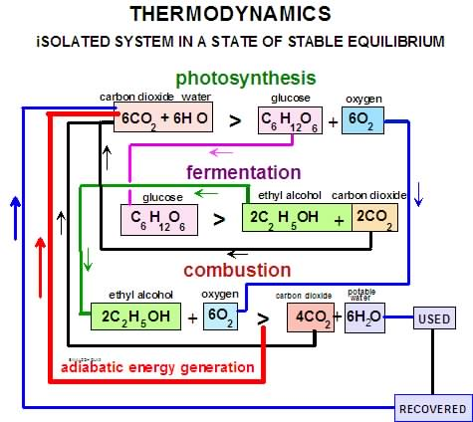

Application of 1st and 2nd laws of thermodynamics
By virtue of the 1st law the energy E of an isolated system is conserved.
The energy “consumed” or “degraded” is not lost but according to the 2nd law is converted to heat at a higher level of entropy. Therefore the equation E = mc² also requires that the mass of the system is also conserved.
According to the present disclosure the same reasoning can be applied on a global scale whereby closed captive carbon photosynthesising systems generate non-carbon fuels as by-products.

The argument for adiabatic energy generation
The efficiencies of the above described cyclic reaction relating to the present invention are limited by the dictates of the 2nd Law of Thermodynamics involving the concept of “Entropy” when considering isolated systems. As with the concept of “perpetual motion” the present concept of “perpetual cyclic energy generation” can only be approached.
There are therefore significant advantages in employing conventional “renewable energy sources” to supply the “make-up” energy required to achieve perpetual cyclic energy generation as illustrated above:
- The transmission of energy by fibre-optics enables the positioning of closely packed embedded LASER or LED elements within bioreactors fitted with transparent or translucent serpentine piping and contained crop growth units thus achieving far more efficient and improved rate of photosynthesis (gm/cm² /sec) of biomass and crops. Preliminary calculations indicate that sets of laser-batteries or gas discharge units fitted to serpentine bioreactors and enclosed farming units with a floor space of for example 50m² can produce the equivalent quantity of biomass as from 1km² of open water or irrigated prime agricultural land and with a minimal negative impact on the environment.
- Added to this is also the theoretical possibility of the transmittal of high voltage pulsed laser beams with narrow bandwidth over long distances by means of fibre optic technology to enable the photosynthesising process to take place at distant power generating sites. Such light pulses with intermittent periods of light and darkness can be tailored to fulfil the optimal combinations for the photochemical reactions associated with photosynthesising processes.

I) Fig.1a/b illustrate flow-sheets based on cyclic captive carbon systems represented as chains of four separate reactions, whereby, in the course of a chain reaction, by-products consisting of oxygen, hydrogen, nitrogen and potable water are produced.
The links of the cyclic chain reaction consist of the following four consecutive reaction steps:

- Photosynthesis
- Bio-digestion/ -fermentation
- Catalytic reforming
- Combustion
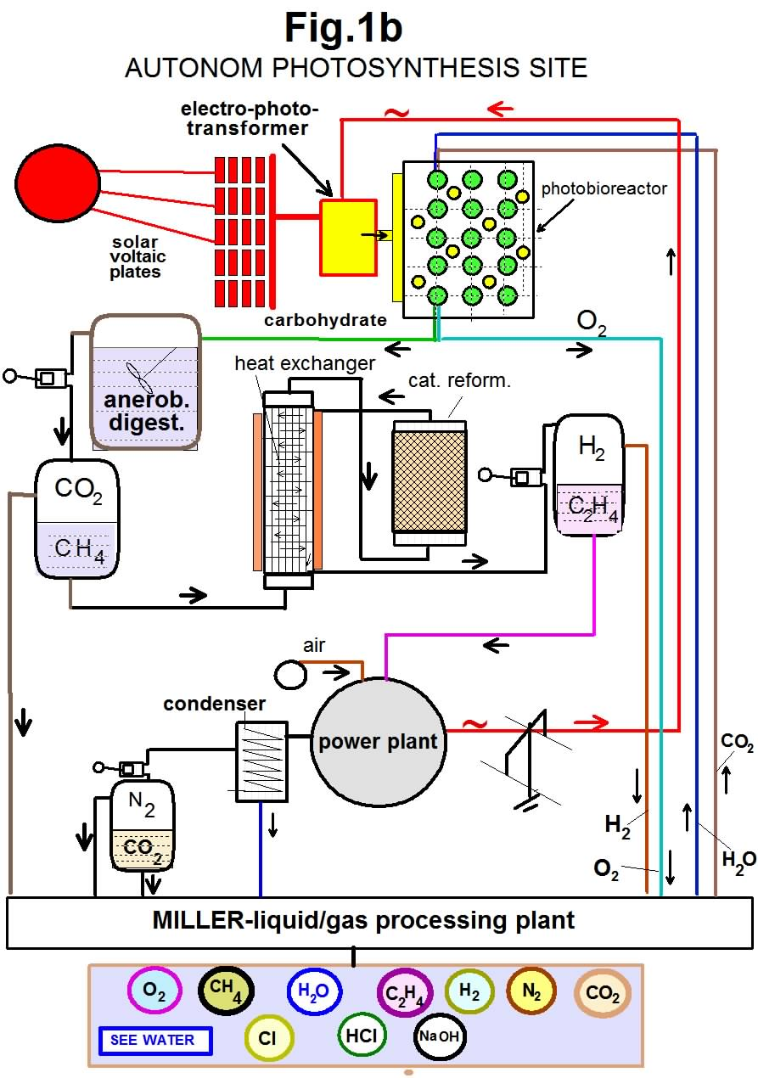
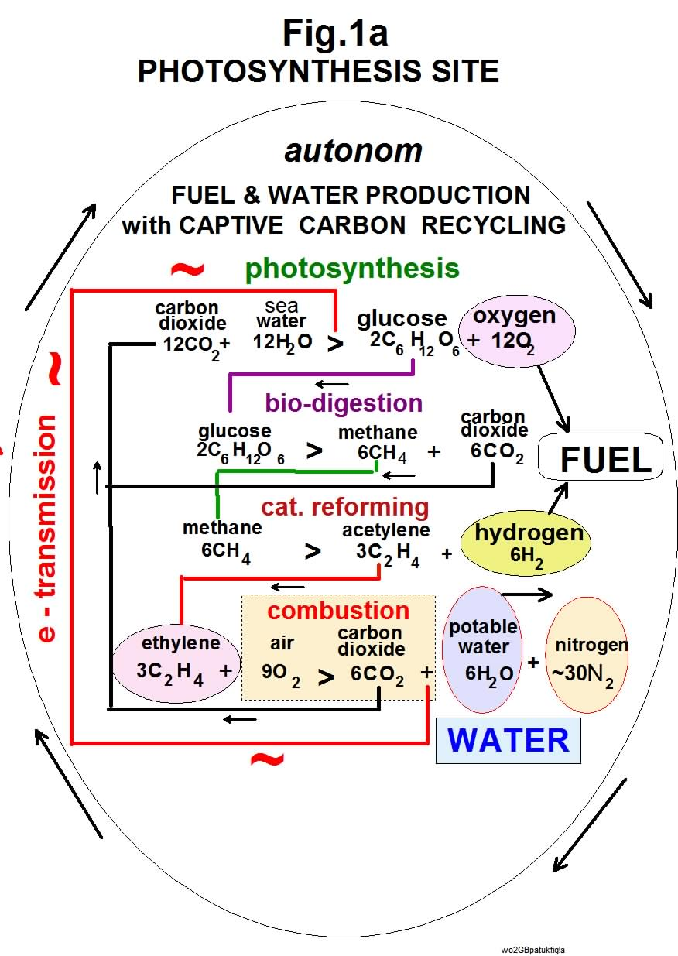

This captive carbon reaction cycle is closed by recycling the carbon dioxide produced in the photosynthesis and bio-digestion steps and the generated electric current in the combustion step for the purpose of irradiation in the photosynthesising stage.

Effectively 12 moles of carbon dioxide produce as by-products 12 moles of oxygen, 6 moles of hydrogen, 6 moles of water and approx. 30 moles of nitrogen.

The flow-lineation Fig.1b of the process shows how the inevitable increase in entropy of the system due to internal energy degradation is compensated for in this case by external solar voltaic panels contributing to electro-photo-transformers producing a source of narrow-banded electro-magnetic wave-beams driving the photosynthesising reaction within the photobioreactor, whereby the bulk of the photon energy is provided by the output of a power plant utilising the entire photosynthesised carbon from the bioreactor in the form of unsaturated hydrocarbon as fuel.
The methane from the anaerobic digestion step is catalytically reformed to produce unsaturated hydrocarbons (e.g. ethylene/acetylene) and hydrogen gas that after purification in the liquid/gas processing plant are stored with the oxygen produced in the photobioreactor as fuel.
Water
Fig.1a shows that 12 moles of recycled or sea water are used in the photosynthesising equation. This results in the production of 6 moles of potable water in the final combustion step and 6 moles of hydrogen gas in the catalytic reforming third step.

Economics of photosynthesized HYDROGEN / OXYGEN
The production of hydrogen und oxygen as by-products according to the system and process illustrated in Fig.1a/b indicates that the predicted crisis immune selling price of the fuel HYDROGEN & OXYGEN would be in the vicinity of $1 -10 / metric ton whereby the combustion reaction is represented by 2H₂+O₂ > 2H₂O and contrasts markedly and favourably with a present selling price of conventional hydrocarbon fuel of the order of $700,--/metric ton

Of special interest is the potential application of fuel cells for the electrification of transport by the combustion of hydrogen and oxygen or air with water as the condensed product of combustion stored and used as a source of trade.
Fuelling land, sea and air transport with hydrogen and oxygen/air would solve much of the existing global political, economical and environmental problems arising from the present global dependency on fossil fuels.
There is still no realistic global solution to the following negative impacts from global fossil fuel combustion:
- Rapid dwindling of deposits of fossilized carbon
- Greenhouse gas emissions
- Water vapour emissions
- Heat input into the atmosphere
- Increasing marine/land water pollution and spillage from exploration and exploitation
Alone the crisis immune cost incentive of HYDROGEN / OXYGEN fuel according to this disclosure would have an enormous positive impact on the global economy as well as the global environment.
II) Cyclic autonomic agriculture
Contemporary global agriculture is still based on practices originating in ancient civilisations and still subject to the repeated drawbacks of drought, floods, pest damage, water shortages and wasted fertiliser.
Fig.2 illustrates a system of agriculture far removed from the days of the pharaohs and more akin to the days of the internet and space travel.
The element carbon of course is at the core of any terrestrial agriculture and also takes centre stage in the agricultural plan illustrated in Fig.2
In this system no earth is ploughed and no fertilisers are wasted. In fact the growth units are supported on strips of impervious slab-material that support internally irrigated layers of aggregate material suited for root growth.
The agricultural system in Fig.2 approaches an autonomic agricultural system based on a scheme according to the principle of TOTAL RECYCLING.

OPERATION
Genetically modified (GM) fast growing plants produce edible crops and waste biomass. The crops are consumed whereby the totality of the carbohydrate waste is subjected to biological digestion and/or direct combustion.
The aqueous irrigation with rest-nutrients are purified In the fluid processing plant and recycled to the sealed crop containers irradiated with pulsed laser or gas-discharge electromagnetic beams with a chosen optimal narrow band of wave lengths generated by power stations largely fuelled in effect by the retrieved biowaste.
Harvesting and planting are carried out on a
permanent basis round the clock and years, whereby the circulating carbon dioxide is set at an optimal concentration and temperature at all times.
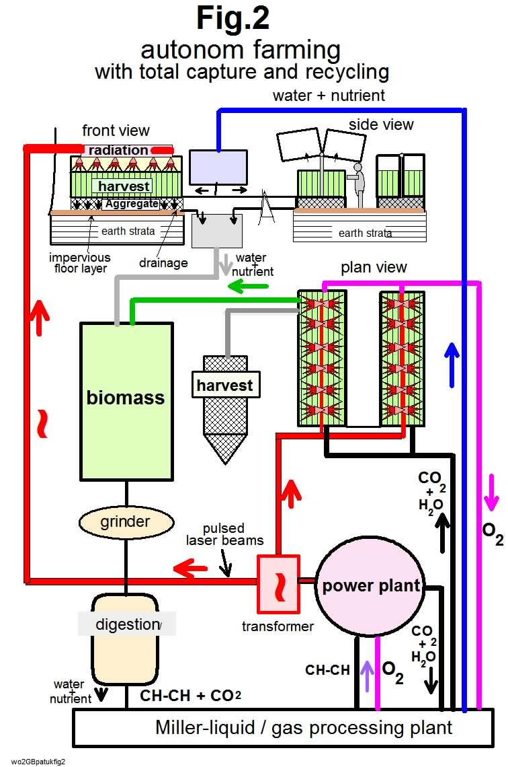

The system is essentially closed, cyclic, autonomous and independent of all weather conditions, latitudes and longitudes.
There is no known globally applicable agricultural technology to cope with the increasing contemporary incidences of extreme drought, flooding and freezing conditions continuing across the world that are causing serious global food shortages with concomitant prohibitive price increases for staple foodstuffs.
Autonomous farming with total capture and recycling is an answer to the contemporary and looming burgeoning population and global food problem.

III) Cyclic autonomic photosynthesized potable water, hydrogen and oxygen from seawater.
Competitiveness:
Potable water, hydrogen and oxygen as byproducts of industrialised cyclic photosynthesis according to the present disclosure have an inherent major advantageous cost structures compared with any other known fuels and sources of desalinated seawater.
Fig.3a illustrates Photobioreactors consisting of clusters of transparent serpentine conduits interspersed with sealed transparent cylindrical elements capable of transmitting
- reflected solar rays;
- laser rays of selected wave length and intensity;
- gas discharge rays of selected wave length and intensity;
- emissions from light diodes with chosen wave lengths and intensity.

for obtaining optimal photosynthesis of suspensions of mainly algal growth within seeded and carbonated aqueous water flowing through the conduits in an upward direction whereby evolved oxygen or hydrogen rises to the upper portions for collection and removal from the reactor.
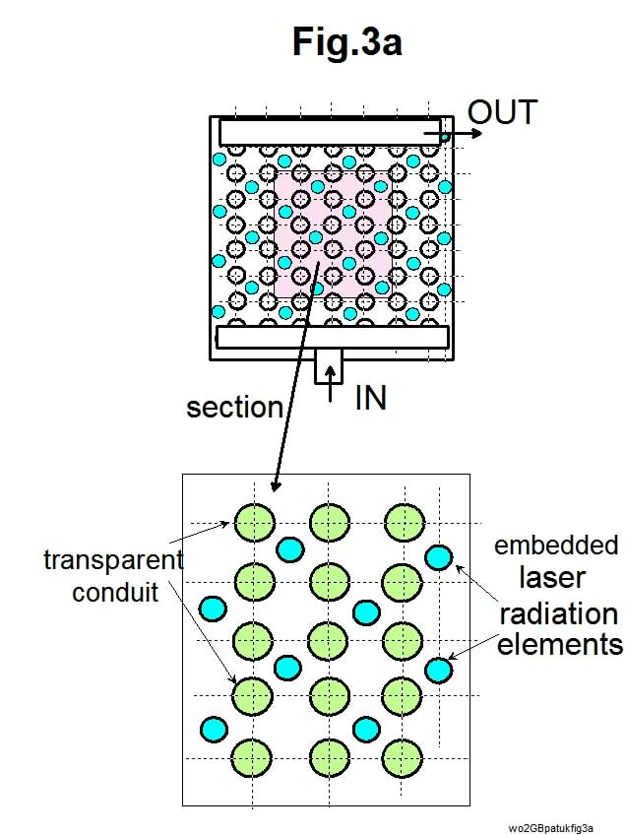

Fig.3b/c: in the presence or absence of sulfur-ions (e.g. sulfides) in the aqueous media making up the photosynthesising process hydrogen instead of oxygen can be produced as by-product.
These autonomous photosynthesising sites for the production of non-carbon fuel for both means of transport and energy generation make up the basis for a global network of linked energy and potable water producing facilities.

These cyclic photosynthesising sites produce desalinated water from sea or brackish water with hydrogen and oxygen as by-products and are a potential source of both potable water and non-carbon fuel that could constitute the solution to the present global demand for non-polluting energy generation, transport and potable water.

The economic factor
There is no inherent reason why a kilogram of photosynthesized potable water or hydrogen/oxygen fuel from seawater should not cost in the region of the price of town water in industrialized countries.

State of the art of water desalination
The operating costs of Reverse Osmosis and Thermal Plants are high and can vary widely. For instance they are subject to to the following serious disadvantages:

- Membrane fouling of reverse osmosis (RO) plants cause frequent renewal of the elements often leading to failure of the plant and excessive expenditure.
- The disposal of both raw water pre-treatment and post-treatment sludges and suspensions can cause excessive unplanned operating costs and environmental pollution problems.
- The fossil fuel energy requirements of both RO and THERMAL desalination of saltwater are high and the resulting carbon emissions indirectly cause further costs. .
Photosynthesising process for sea- / brackish water desalination and hydrogen and oxygen production according to the invention

OPERATION
With this process sea or brackish water partially saturated with purified carbon dioxide is passed through novel photo-synthesising bioreactors where in effect water molecules in the seawater are decomposed by photons to protons and atomic oxygen whereby the protons enter into a cyclic catalysed reaction with carbon dioxide to produce carbohydrates.
In effect molecular oxygen is set free as a by-product for storage or recycling to the power generator for combustion with fuel originating in the photo-synthesising bioreactors thus closing the cycle.

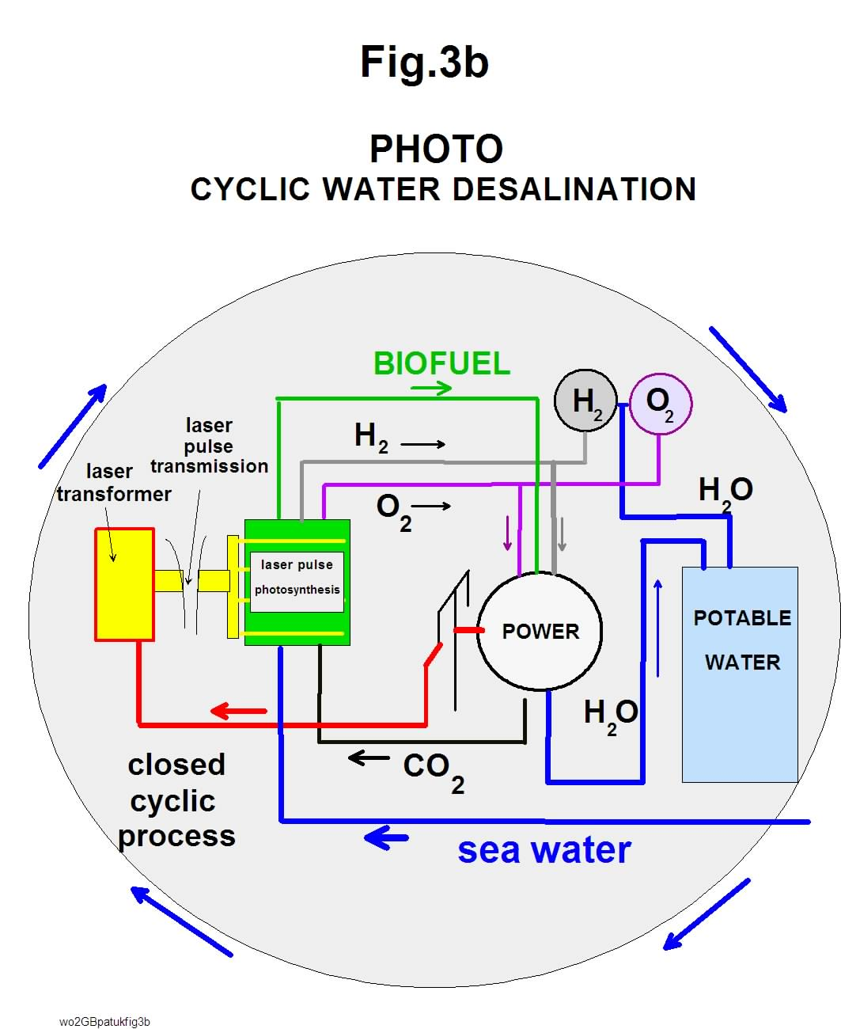
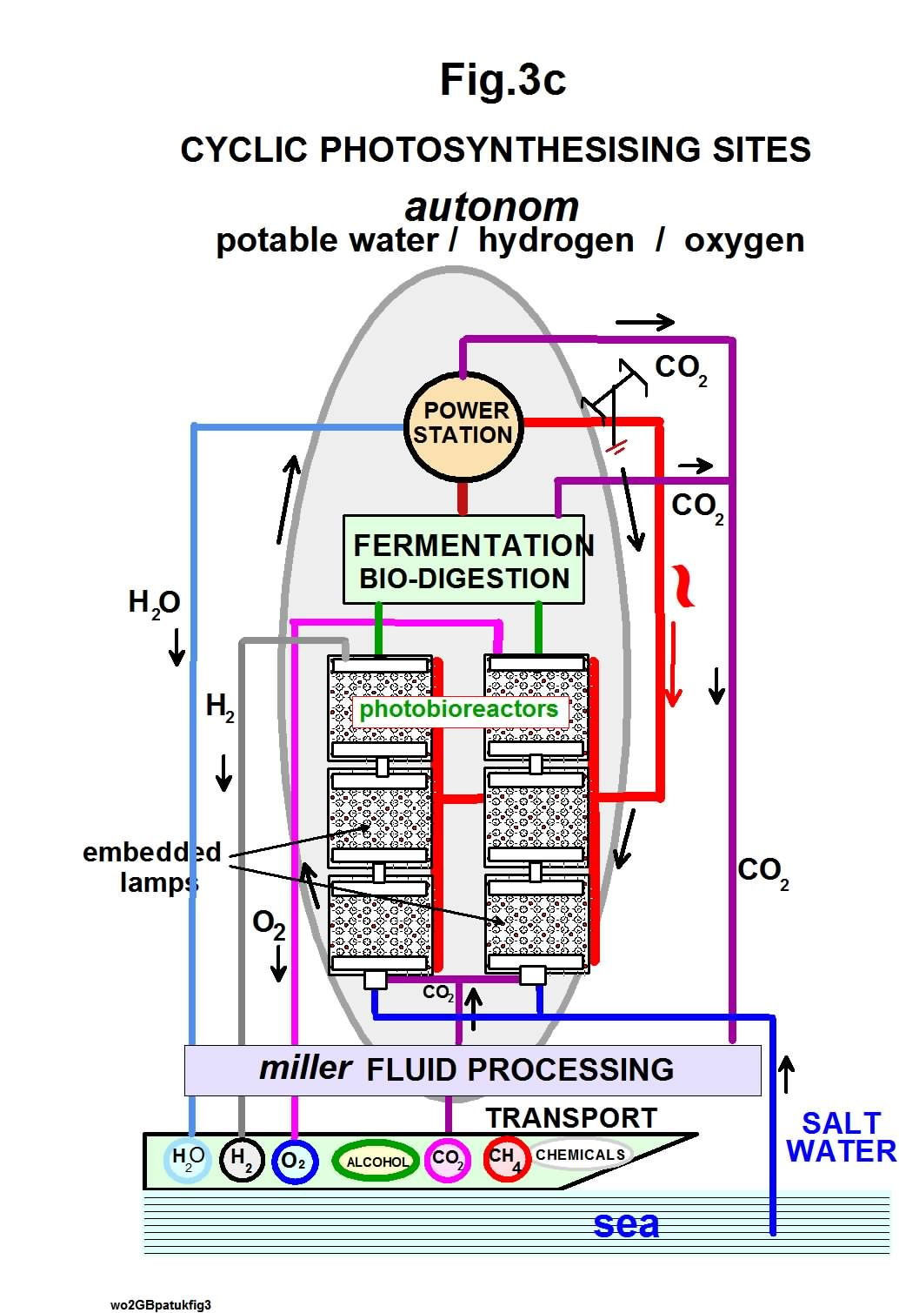

The mechanism of demineralisation according to the illustrated processes cannot be compared with conventional thermal and filtration systems. The e-power generated from biomass combustion is converted into electromagnetic radiation consisting for example of a narrow band of photosynthesising wavelengths (400-500nm) of laser or gas discharge beams to convert the energy into carbohydrates (biomass) for further combustion and energy generation thus completing a system of closed cyclic photosynthesis.
Therewith a significantly improved efficiency of the photosynthesising reaction is achieved compared with direct solar radiation:
- it is reasonable to assume that by applying this technology at least a ten- to twenty-fold increase in the efficiency of utilising of sunlight can be achieved..
- An additional advantage is that an effective further doubling of the efficiency of utilisation is achievable with the prospect of round-the-clock uninterrupted production
- A fuel and potable water producing system largely independent of other external sources of energy is thus achievable.

With this in mind an autonomic photobioreactor site requiring 1-2 hectares of space in improving on nature’s yield of marine algal matter could produce 400 ton/h biomass resulting in ca.200 tons/hr or ca. 5000 tons/day of potable water according to the present invention.
Accordingly, for a population 50000 ca. 100 litres / person / day of potable-quality is made available.

Comparative costs of desalinated seawater
Preliminary calculations indicate that the production cost of potable water from saline water by photosynthesis undercuts the nearest competitive process of Reverse Osmosis by approximately 50% with the added advantage that there are no emissions of green house gases and there are no emissions of environmental damaging liquid effluents.

_____________________________________________________________

1. Process of the invention
Energy minimal
Capital amort.. 90%
Operating 10%
$0.4 / ton (metric)

2. State of the art
Thermal Reverse Osmosis
Energy 50% 30%
Capital amort.. 50% 40%
Operating 25% 30%
~ $1.5 /ton (metric)
__________________________________________________________________________________

IV) Autonomic photo-biomass with by-product non-carbon fuel and potable water
The contemporary trend of resorting to “biofuels” in the form of vegetable oils, fats and alcohol from the edible parts of food crops have, apart from the high price for such products, caused a market short fall in crop foods available to hunger-stricken parts of the world.
The cost of harvesting and the continuing need for extra fertilisation and irrigation over extensive land areas is hindering the realisation of such proposed solution to the fossil fuel crises.
In addition the green house gas emissions of biofuel combustion are almost identical to those of fossil fuels whereby the “carbon-neutral” benefits claim is spurious.
Fig.4a illustrates schematically an autonomous enclosed photosynthesising site suitable for satisfying the cost and environmental issues concerning fuel and potable water demands.
Such covered autonomous agricultural and production facilities can produce, in addition to biomass for fuel production, a wide variety of agricultural food products.
These photosynthesising sites can be ideally established for supporting clusters of existing small to medium-sized communities in existing industrialized or developing countries
For example hundreds of such sites spread over a typical industrialised landscape would achieve the decentralization of civilian and industrial demand for energy with the complete elimination of greenhouse gas emissions, effluent pollution and the need for fossil fuels. Each site could be capable of comprehensively supporting an optimal surrounding population of ca.100,000.
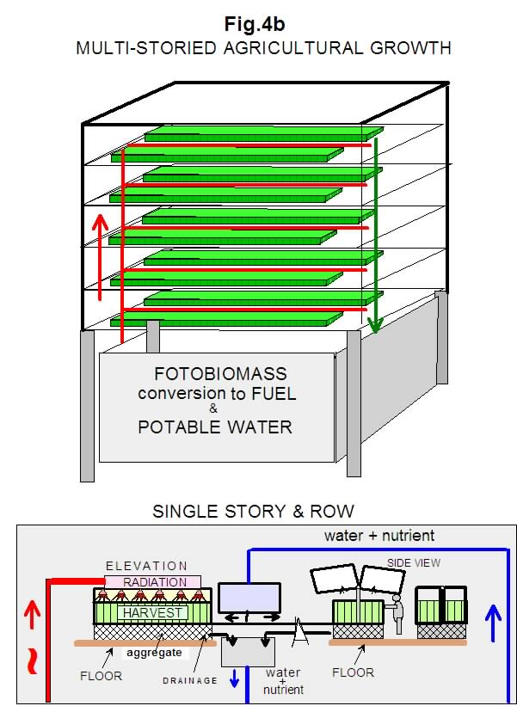
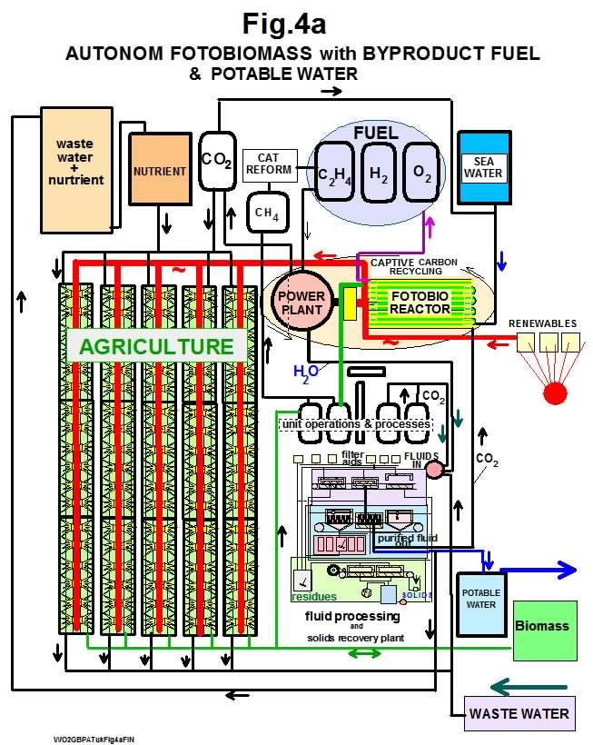
Fig.4b illustrates schematically a space saving and highly automated system for the same photosynthesising purposes.
These multi-storied autonomic photosynthesising sites are predestined to solve the problems associated with today’s agricultural practices:
- Independent of weather conditions
- Pest-free conditions of growth enabling the elimination of pesticides
- Complete recovery and recycling of nutrient irrigation
- High degree of automation (harvesting, bed renewal, planting, irrigation)
- Large tracts of previous agricultural land can be returned to natural ecological landscapes
- Continuous planting and harvesting the year round.

V) Closed PHOTOchemical complexes to replace fossil-carbon consuming PETROchemical industries
Fig.5a-d represent the reactive concept and flow-sheets of industrial units for the realisation of recyclable carboniferous products based on photosynthesis with the production of non-carbon fuel as byproducts.
Illustrated is an array of carbonaceous products for trading purposes that are produced in photosynthesising production facilities including standardised universal fluid and solids processing equipment such as reactor-, distillation-, heat exchanger- units, with CIP (cleaning in place) facilities, whereby shuttle packed beds carry out unit operations involving adsorption, ion-exchange, catalysis, drying operations traditionally carried out by custom made packed towers, columns, cylinders specialising in single products.

These sites carry out closed cyclic chain reactions with the following steps:

photosynthesis,

bio-digestion,

catalytic reforming,

polymerisation

combustion
whereby provision is made for the production of a comprehensive range of carbon based products.
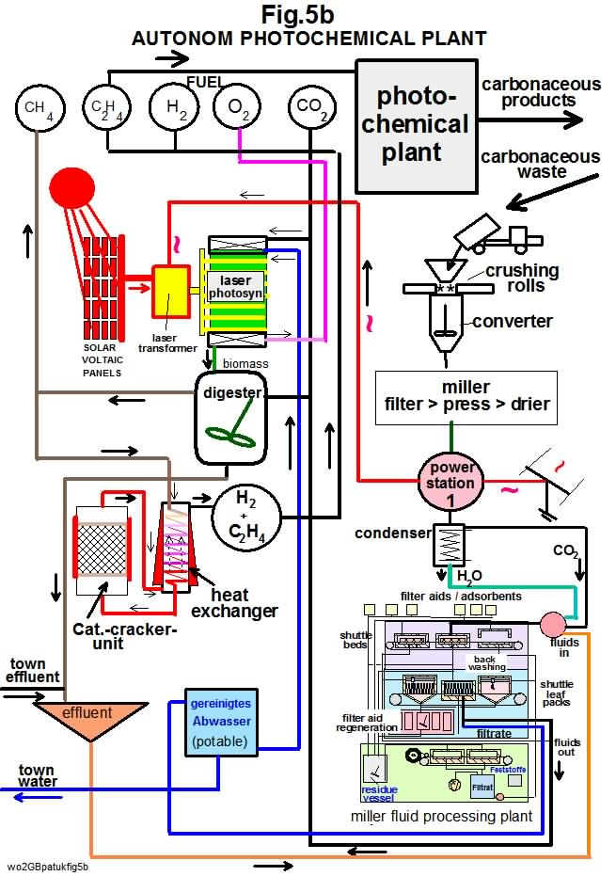
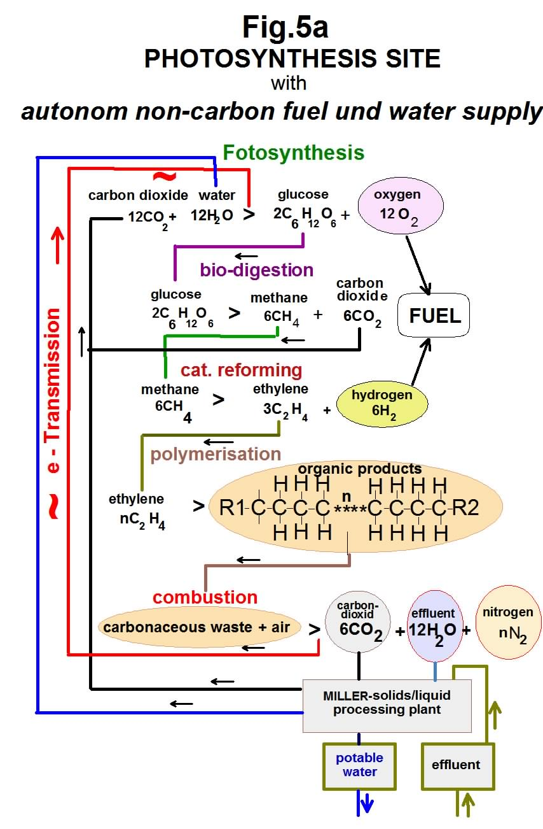

Sequence of operations:
- In the first photosynthesising step carbon recycled as carbon dioxide is fixed as carbohydrates in photobioreactors, whereby producing oxygen as a byproduct.
- In the second link of the chain-reaction carbohydrates are digested or fermented to produce hydrocarbons and carbon dioxide;
- In the third link of the chain-reaction the hydrocarbons are catalytically reformed to produce unsaturated hydrocarbon compounds with at least hydrogen gas as a byproduct.
- In the fourth link of the chain reaction the unsaturated hydrocarbon compounds are polymerised to produce a wide range of carbonaceous compounds and products of commercial value suitable for recycling after use
- in the final link of the chain-reaction, recycled waste carbonaceous matter and products are combusted to generate electricity with water and nitrogen as byproducts; whereby the generated electricity provides the energy for irradiating the photosynthesising step thus largely closing the energy cycle, wherewith the carbon dioxide emitted in the digestion and combustion processes is recycled to the photobioreactors to close the carbon cycle; whereby water is conserved and reused indefinitely throughout the site; whereby external demands for city water are included in the cyclic process

Fig.5c:is an alternative version of the above Fig.5b whereby a more comprehensive diagram of the recycling of carbonaceous waste of polymeric materials after use is illustrated.

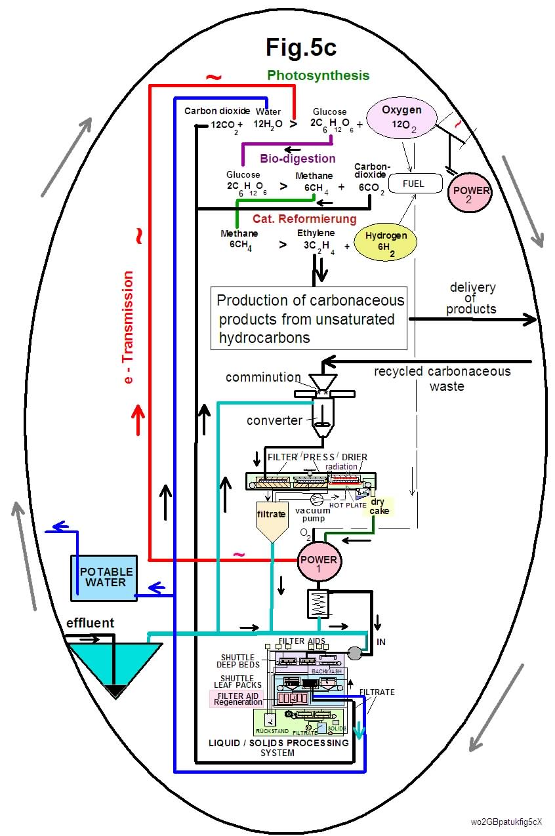

This waste material comprising large quantities of plastic matter originating from existing fossil-chemical industries and now posing an ever-increasing environmental threat; is, according to the present disclosure, comminuted, filtered, pressed and dried before firing in a power plant whereby the electric current generated is transformed to light bundles for photosynthesis and the accompanying water vapour from combustion is condensed and subjected to searching purification in the miller Liquid-Solids-Processing-System to produce both recyclable potable and photosynthesis water.

Fig.5d illustrates a plan for the production of a large variety of photochemical products each for instance on a weekly or daily basis over the course of a year.
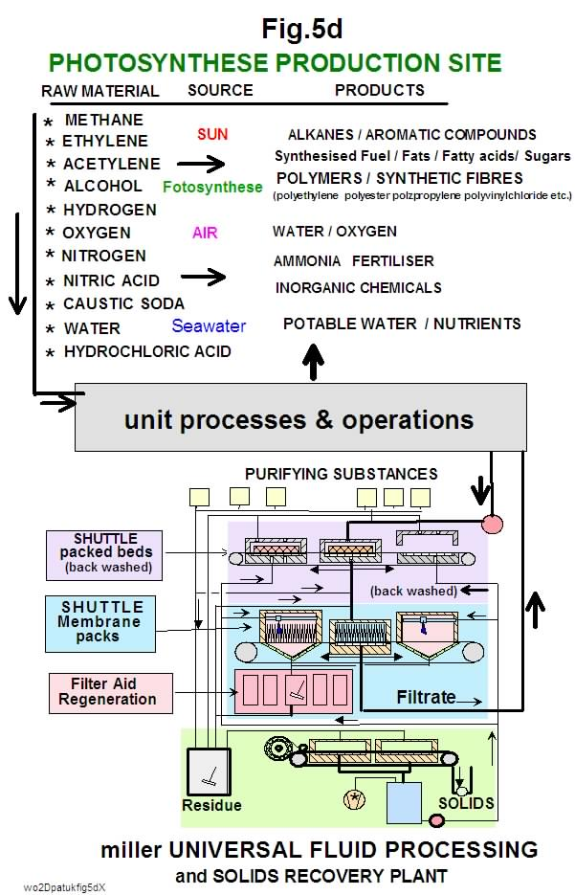

The key to this plan can be seen in the innovative concept already disclosed in WO2009/034365 and GB0821653 whereby fluid processing, purification and recycling and solids recovery systems and apparatus are capable of handling a wide range of operational requirements.

VI) Fig.6 illustrates photosynthesizing sites for the conversion of existing fossil fuel power plants to CAPTIVE CARBON RECYCLING mode of operation.
The present infrastructure associated with fossil fuel production, energy generation and distribution represents an investment perhaps in the region of hundreds of trillions of dollars or euros. Existing fossil fuel polluting power plants have the option of importing or producing on-site recycled photosynthesized fuel to maintain a large proportion of existing power stations.

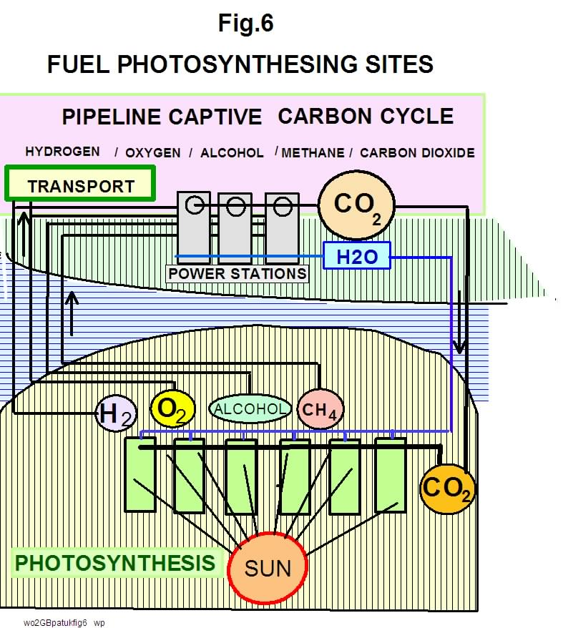

The present disclosure deals with the means for exploiting the advantages of closed cycle chain reactions on a global scale to solve not only the ever diminishing reserves of fossil fuel deposits and existing emission problems but also the increasing global dependency on the ever increasing manufactured carbonaceous products.
Emissions into the environment are thus avoided on a global scale while the economic advantages of a carbon-led economy are preserved.
Carbon dioxide also becomes a valuable global trading commodity, whereby the current combustion of ca. 2 billion tons/year of carbon with the accompanying carbon emissions could conceivably be cut to near zero over the coming decades and therewith instead of being a scourge on humanity carbon dioxide will become a valuable much sought after commodity.
The implications go much further:-
Carbon dioxide, seawater and solar energy is the concoction of nature that led to nature’s and man’s success. It was mainly from this combination that life on earth evolved and thrived and by building on and exploiting nature’s accomplishment we can assure our future successful existence.
The almost unimaginable prospect of transporting seawater through networks of conduits throughout existing landmasses to provide new productive human habitats and energy generation may transcend science fiction and become a reality.
The inherent uncertainties concerning trends of climate change makes it imperative to provide new affordable sources of pure water as well as emission-free affordable energy and transport for present and future generations that are unchanging, reliable and sustainable.

Summing up
The combination of the sun, carbon dioxide and seawater can fulfil these requirements.
However the most serious contemporary dilemma facing the carbon-cartels is the rapid disappearance and ever increasing cost of suitable fossil carbon in the earth’s crust as the continuing basis of the global industrial complex.
Today’s trend towards centralization of energy generation, industries, financial districts and burgeoning population conurbations are becoming increasingly threatening to the stability of global economies.
The need for decentralization has been on political agendas for many decades, however state of the art technology is not suitable for achieving such plans and coupled with the lack of backing for protagonists of innovative technology no promising long term plans have yet been realized.
Progress in energy generation up till now has mainly consisted of the subsidized expansion of expensive old technologies intended eventually to compete with the ever-increasing rise in the cost structure of conventional fossil fuel based energy generation with almost no regard to the ever-burgeoning rising prices of carbon-based products and the accompanying ever-increasing environmental damage of emissions and waste-dumping into the environment, the earth’s crust and seas.

The key to a breakthrough must be based on the realisation that the world can’t turn its back on carbon as the underlying foundation of a stable long-lasting future for the human race.
The medium term plan therefore must be to replace fossil carbon by photosynthesised carbon and non-carbon fuel within the next two decades.
Over the past century we have witnessed an explosion in the replacement of naturally occurring products originating from plant and animal sources by synthesised products based on fossilised carbon. Huge fossil fuel, chemical and pharmaceutical complexes and cartels now dominate the production of the bulk of synthesised commodities replacing naturally occurring raw products ranging from pharmaceuticals, plastics, fibres, solvents, paints, surfactants disinfectants, pharmaceuticals, pesticides, etc. A multitude of such production facilities is also the source of the contemporary most dangerous pollution of land, sea and air resources of the planet.
However the most serious contemporary dilemma facing these cartels is the rapid disappearance and ever increasing cost of suitable fossil carbon in the earth’s crust as basis of the entire carbon-based industrial complex.
An important component of the overall strategy of these sites is not only to decentralise industrial complexes but also to provide the means for the decentralisation of the centuries-long continuing trend towards burgeoning over-concentration of human mega-conglomerations across the globe.
The further major goal of the present disclosure is to replace the ever burgeoning centralised petrochemical cartels and complexes with decentralised photosynthesising photochemical
sites dispersed over wide areas of the globe with the means for the catalytic reforming of photosynthesised methane, alcohol, etc. to a large range of organic chemicals including
- non-carbon fuel for energy generation
- the indirect isolation of mole-equivalent quantities of hydrogen, oxygen for transport and energy generation application as well as equivalent quantities of nitrogen and potable water

The main task can be achieved by the establishment the comprehensive recycling of carbon and all other valuable elements making up the table of elements.

CLAIMS
1. Globally located photosynthesising sites consisting of closed cyclic systems to mitigate manmade climate change tendencies, solve environmental pollution and scarcity of natural resources especially fossilised carbon, food and potable water; thereby providing the basis for the decentralisation of industrial and urban mega-complexes by means of combinations of the following technologies:-
- means for achieving the global autonomous production of non-carbon fuel and potable water;
- means to achieve global autonomous agricultural sites;
- means for the realisation of global autonomous production of potable water from seawater;
- means for achieving the global autonomous production of agricultural biomass for the production of non-carbon fuel and potable water;
- means for the realisation of closed global carbon cycles, autonomous production of carbonaceous products suitable for recycling as fuel for firing power stations thereby decisively contributing to the realisation of closed global carbon cycles for energy generation, agriculture, carbonaceous products and the availability of potable water.
- means for the conversion of global fossil fuelled power stations to autonomous captive carbon power stations.

2. Photosynthesising sites for the autonomous production of non-carbon fuel and potable water according to claim 1a) and fig.1a/b, whereby in a closed set of linked cyclic chemical reactions
- firstly, carbon recycled as carbon dioxide is fixed as carbohydrates in photobioreactors, thereby producing oxygen as a byproduct;
- whereby in the second link of the chain-reaction carbohydrates are digested or fermented to produce hydrocarbons and carbon dioxide;
- whereby in the third link of the chain-reaction the hydrocarbons are catalytically reformed to produce unsaturated hydrocarbon compounds with at least hydrogen gas as a byproduct;
- whereby in the forth and final link of the chain-reaction, reformed unsaturated hydrocarbons are combusted to generate electricity with water vapour and nitrogen as byproducts; whereby the generated electricity provides the energy for irradiating the photosynthesising step thus thermodynamically closing the energy cycle, whereby the carbon dioxide emitted in the digestion and combustion processes is recycled to the photobioreactors to thermodynamically close the autonomous carbon cycle.

3. Photosynthesising sites for contained agricultural crop growth according to claim 1b) and fig. 2, whereby water, nutrients, carbon dioxide and biomass of the process are recycled on a permanent basis; whereby the recycled biomass provides the energy for the photo-irradiation of the crops to approach the condition of thermodynamic autonomous closed systems

4. Photosynthesising sites for autonomous generation of potable water from seawater according to claim 1c) and figs.3, whereby electric power generated from photosynthesised biomass is converted to pulsed optical beams of optimal electromagnetic wavelength for the irradiation of enclosed photosynthesising systems with salt free water, oxygen and hydrogen as by-products.

5. Autonomous photosynthesising site for the enhanced growth-rate of agricultural biomass on a large scale according to claim 1d) and figs.4 where electric power from both power stations and renewable sources is transformed to pulsed narrow beams of optimised photosynthesising wavelengths to produce agricultural biomass in sealed industrial sized agricultural containers arranged either at ground level or in multi-storied buildings.

6. Photosynthesising sites according to claim 1e) and figs.5 whereby provision is made for the production of a comprehensive range of carbon based products, whereby in a closed set of linked cyclic chemical reactions
- firstly, carbon recycled as carbon dioxide is fixed as carbohydrates in photobioreactors, thereby producing oxygen as a byproduct;
- whereby in the second link of the chain-reaction, carbohydrates are digested or fermented to produce hydrocarbons and carbon dioxide;
- whereby in the third link of the chain-reaction the hydrocarbons are catalytically reformed to produce unsaturated hydrocarbon compounds with at least hydrogen gas as a byproduct;
- whereby in the forth link of the chain reaction the unsaturated hydrocarbon compounds are polymerised to produce a wide range of carbonaceous compounds and products for commercial purposes suitable for recycling as carbonaceous fuel after use;
- whereby in the fifth and final link of the chain-reaction, recycled waste carbonaceous matter and products are combusted to generate electricity with water vapour and nitrogen as byproducts; whereby the generated electricity provides the energy for irradiating the photosynthesising step thus largely closing the energy cycle, wherewith the carbon dioxide emitted in the process is recycled to the photosynthesising step to close the carbon cycle

7. Photosynthesising sites according to claim 1f) and fig.6, whereby existing global carbon fuelled power stations are converted to non-polluting captive carbon or non-carbon combustion systems.

Wo2internet2012

ABSTRACT

Disclosed here is a long-term plan for the replacement of the present environmental polluting fossil fuels with sources of fuel for combustion and energy generation and transportation based on solar or autonomic photosynthesis. Globally located photosynthesising sites consisting of closed cyclic systems to solve contemporary, environmental pollution and scarcity of natural resources and food as well as achieve the decentralisation of industrial and urban complexes by means of combinations of innovative autonomous photosynthesising technologies:
Initially the existing global infrastructure of fossil fuelled power stations and the concomitant e-distribution grids will be retained as they represent an enormous investment that are unlikely to be replaced by traditional renewable energy alternatives in the short-term.
Illustrated graphically is how hydrogen and oxygen can be autonomously produced as byproducts of photosynthesising processes thus providing emissions-free energy generation and transportation on land, sea and in the air at a price far under that of contemporary fossil fuels.
Also described and illustrated is a plan for the autonomic growth of food crops and biomass whereby aqueous nutrients and carbon dioxide are recycled on a permanent basis.
This development will favour investment in the realisation of globally situated cyclic autonomous photosynthesising sites including bulk transport infrastructure in sun-drenched regions of the globe to provide fuel and many other commodities for worldwide consumption.
This trend will be supplemented by global networks of self-sustainable photosynthesising facilities for the energy-saving, cost-effective desalination of seawater to provide a climate-immune supply of fresh water to all corners of the globe.

